Evaluation

The website I chose to design is called: “Visit Cardiff”. I thought this would be a very accessible topic which would avoid over-complication yet still look visually attractive.

My process for designing the website was desktop-first, rather than mobile first. I chose to work this way because I think it’s easier to refine elements of a website down than it is to add more things in order to fill up blank spaces. However, I would say that on reflection, the two need to go much more hand in hand that I originally thought.

My design is minimalistic; which is just a personal taste preference rather than a lack of content. The below screenshot is from my MacBook, so is a standard laptop-sized screen.



The colour scheme I chose was purely down to how it looked with the image that I chose for my homepage. I think the pastel coloured blue is just the right hue given the white background behind the elements.

I chose to have my colours and images fill the whole page, again, my personal preference. I had planned this style from when I drew up the design on paper, and I’m happy that the original structure I had in mind not only succeeded, but looked as clean as I wanted it to. I like block elements and colours, so using different shades for each section broke up the page and made it attractive and easier to navigate.

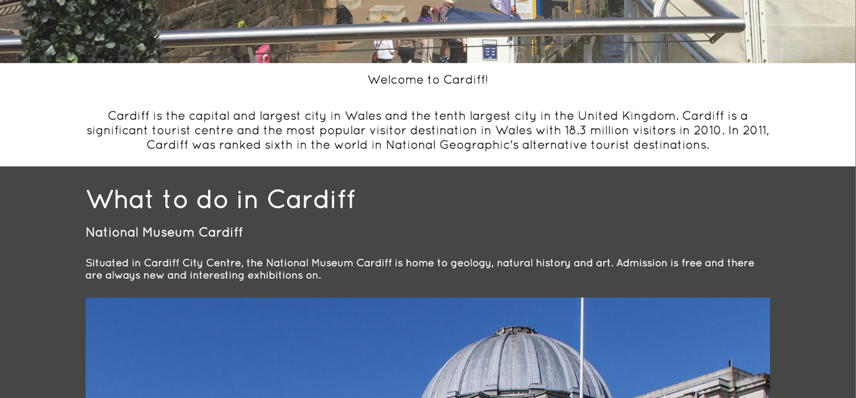

I chose to use a 10 – column grid layout on my website, always keeping 1 column on either side of any element. My source for making and using this grid was in Web Application Development Class with Martin.

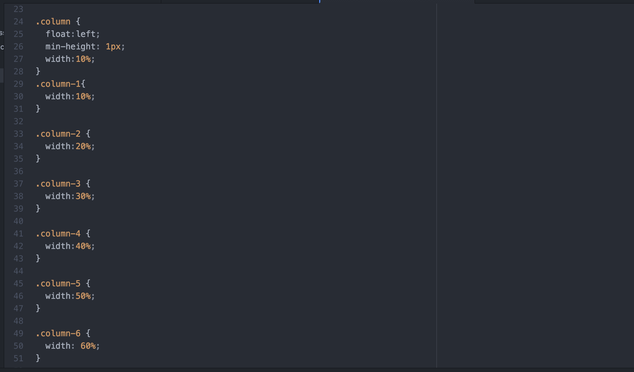

This was a really successful, easy way to design the website and as you can see in the website screenshots, the edges are consistent throughout – the look I was aiming for.

However, I realised the issues with grid layouts when I began making the website responsive, and had massive trouble with elements that were fixed sizes and wouldn’t decrease in size easily. 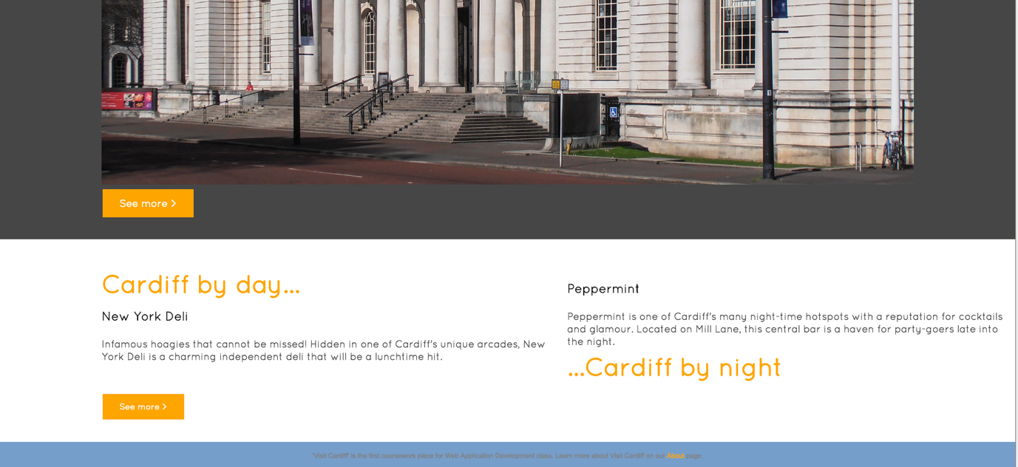

As you can see in the above image, I have two small paragraphs next to each other. When positioned using the grid structure, the columns sat together nicely on the page, but as soon as the page was resized, the two didn’t work with each other and overlapped.

I altered the code by taking out the grid structure for the text, keeping it only for the structure to keep the edges 10% blank either side of the body of the HTML.

Instead, I changed the CSS rules for each element in the code, and arranged the two paragraphs into a table-cell arrangement.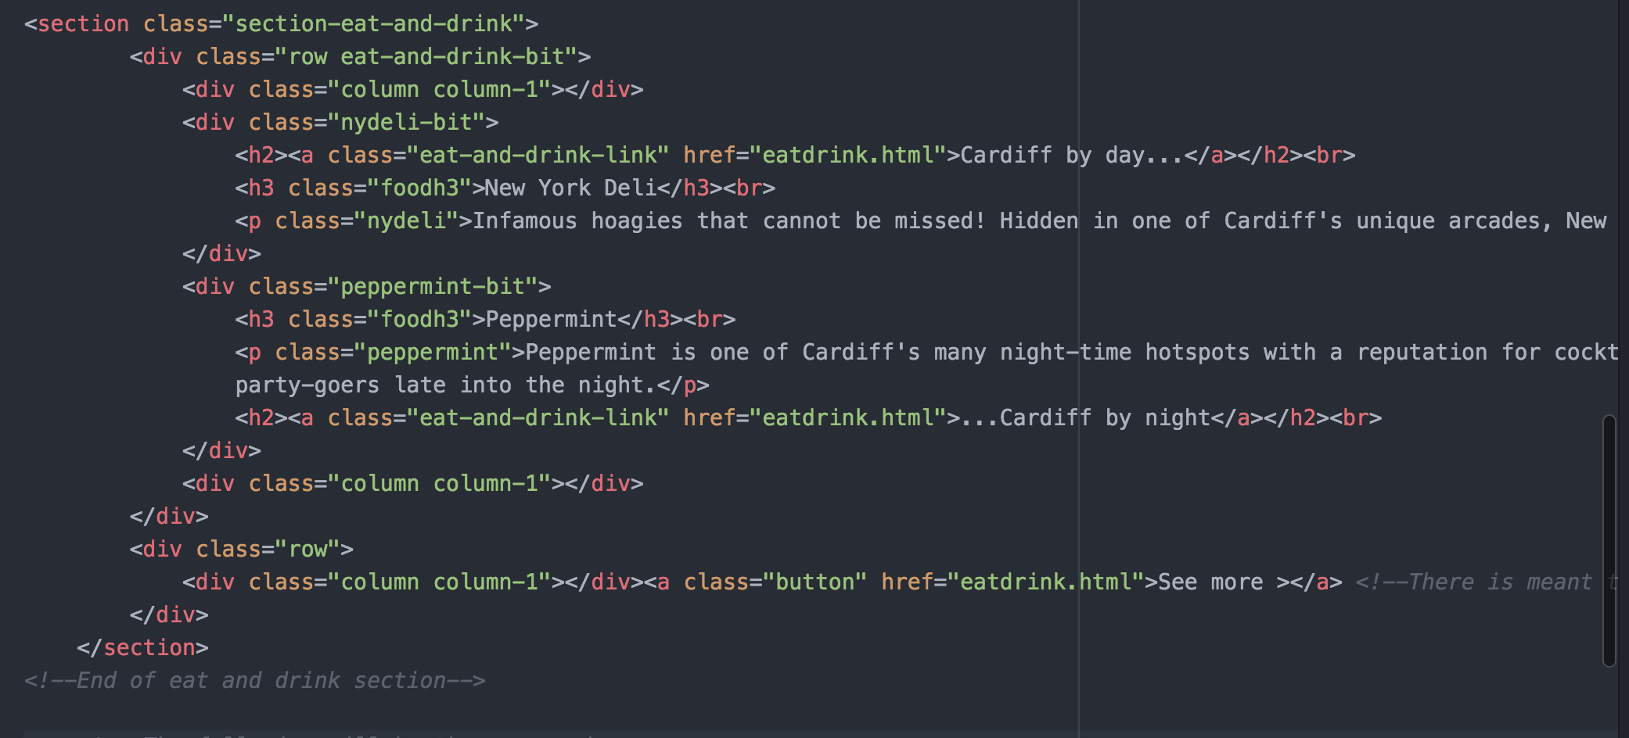

When the page is resized to 375pixels, which is the size of an iPhone 6, the paragraphs sit in block style rather than inline as they do on desktop sized screens.

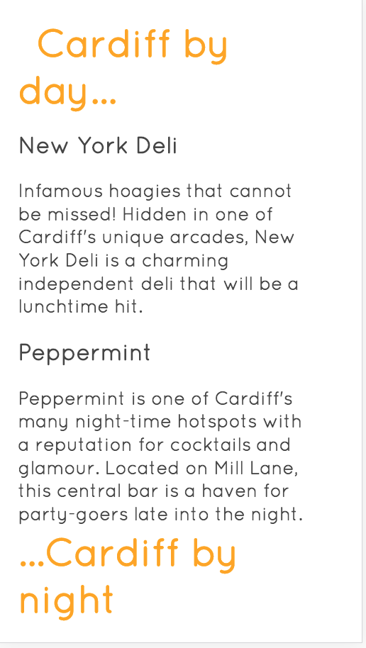

My website has 4 pages, accessible through my navigation bar. I had hoped to have a responsive navbar which would shrink to a ‘burger menu’ when resized, but this is an issue I faced and had to leave (for now).

Instead, I used media queries to resize the font when the screen-size is decreased.

I did a lot of googling whilst making my website, and often I discovered simpler ways of coding things that I was already doing. Two websites I found very useful were: <http://www.w3schools.com> and <http://stackoverflow.com>. The former helped a lot with my navbar, and understanding Ordered and Unordered Lists, and the latter, I visited a lot of forums to solve problems that other people before me had found.

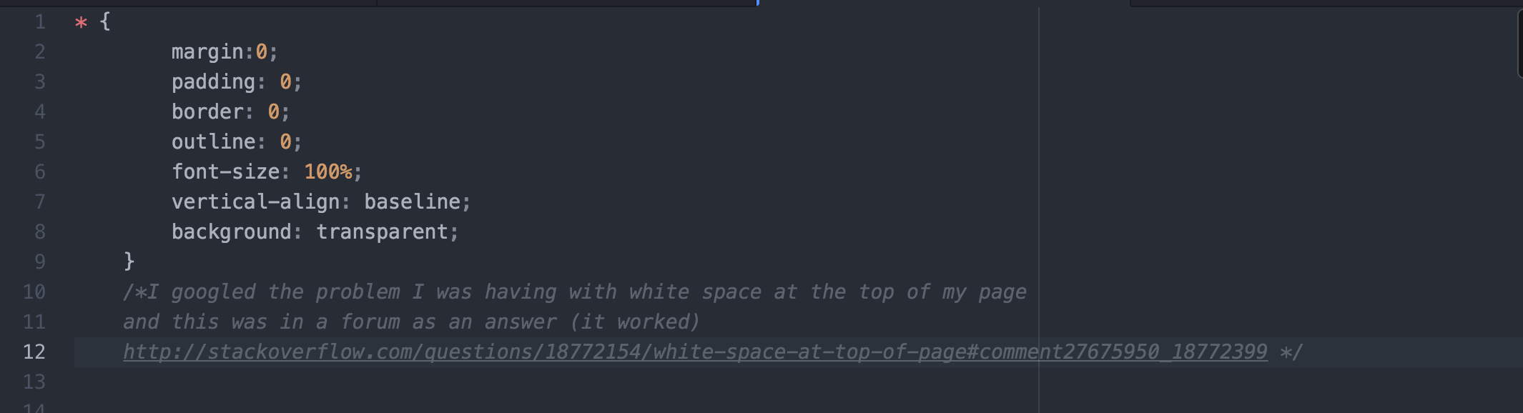

In places that I used code off either of these websites, I have left comments in my code like so in this screenshot, to give credit where due, but also to enable myself to understand what I’ve done and why the code is working the way it is.

I used a google font on my website, and I have used it for the vast majority of the pages. I tested the font in various web browsers including Safari and Mozilla, and the font is successful in all I tried.

I embedded quite a lot of media from various places including: Instagram and Google Maps. I also had a Twitter feed at one point, but found it nearly impossible to make responsive, so didn’t want to risk ruining my page for something that only looked good on screen-sizes 800px or above.

I found that using the provided code from the source of the content was only good for desktop sizes. Given I have used a grid too, I found that trying to resize or manipulate the item was generally unsuccessful, hence the loss of Twitter from my page.

The Instagram images I have embedded in the “Eat and Drink” page on my website is not the finest work that I know I could produce, however I got to the point where I was going around in circles with it.

This first image is the page at full desktop size. The second is the page resized to around 700pixels.

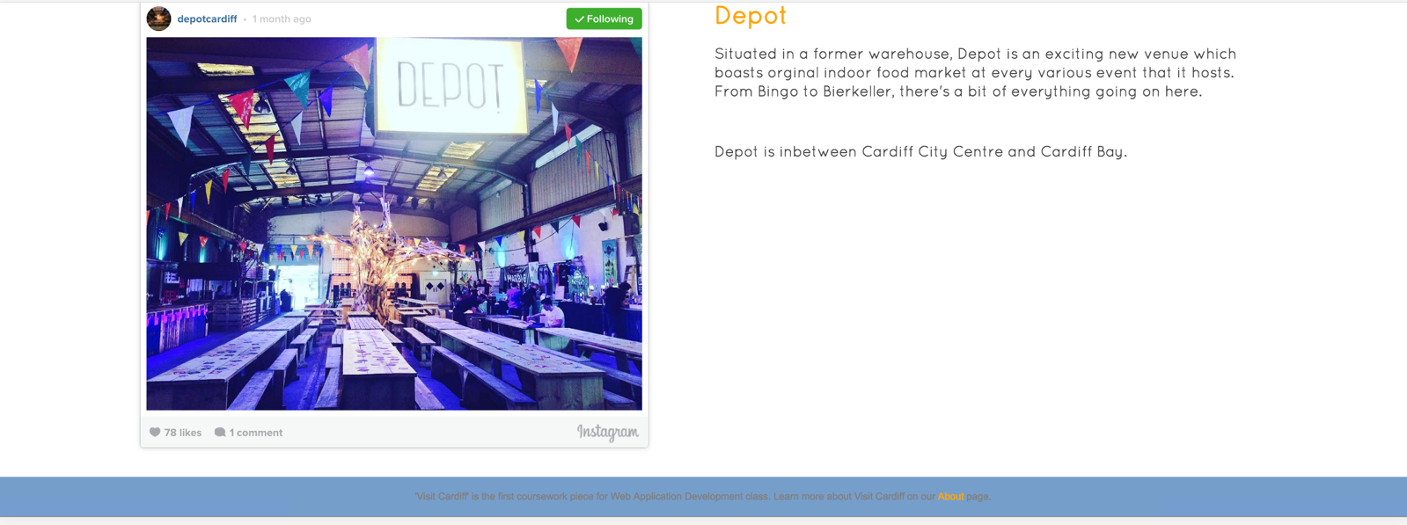

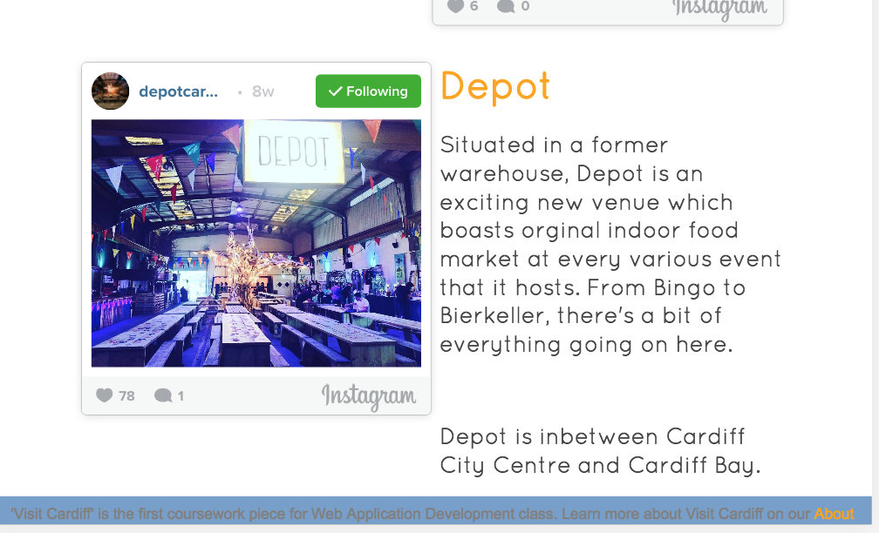

Whilst these sizes both look acceptable, resizing the page any smaller starts to make the elements look too squashed together.

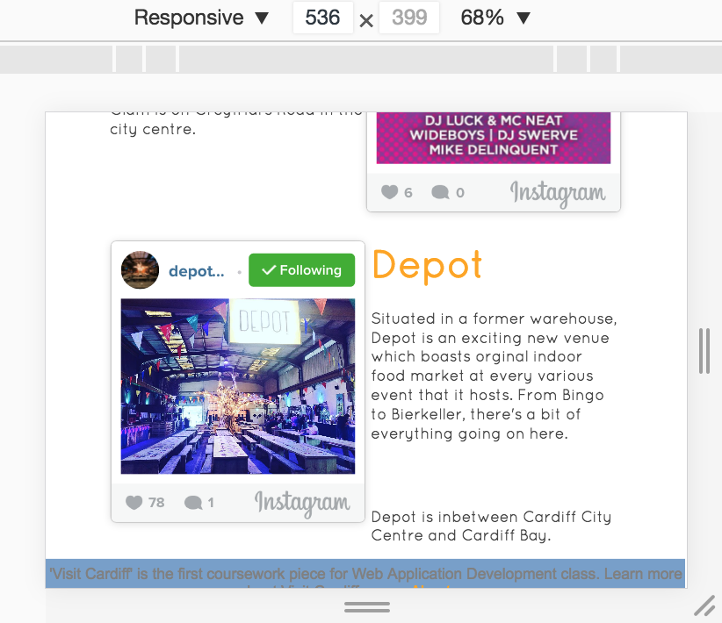

I’m sure that there would have been a way to organise the page better, and it definitely required more planning than went into it, but I was keen to include elements that would be interactive and interesting, so I chose not to take the Instagrams out, as I did with the Twitter feed.

My design, whilst not the most original in the world, was, in my opinion, executed well. The next steps I would make with this website would be to make the navigation bar vertical on the left hand page, and to make it all a little less concrete.

In terms of responsiveness, the website works in every phone size, and is still easy to navigate. The content is readable, and still remains practically uncompromised in the smaller screen sizes such as iPhone 5.

I think to make a better mobile website; the page will need to be more consecutive rather than simultaneous. Items just don’t work inline on small screens, so the page design needs thorough consideration about what will either be removed, or what order items it flow.

The website is definitely a simple design with simple content. All the images used are either my own pictures, or are credited in the code. However, I am aware that in order to publish this website, I would need to credit the owners of the pictures properly by having their names below, or in hover links on the images. Similarly for the text, some is from Wikipedia, but the majority was quickly typed by myself.

An item of the webpage that is unimpressive is the Footer, but I will add that this is because there’s not really much information to go in there, so I left it pretty simple.